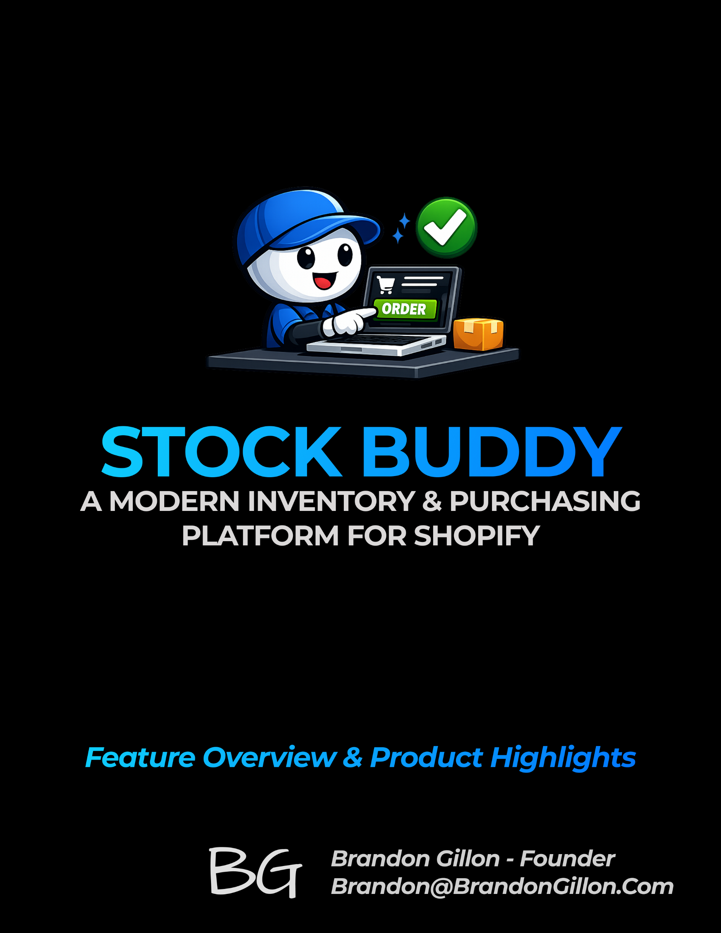

Executive Summary
Stock Buddy is a modern inventory and purchasing platform built specifically for Shopify merchants who need accuracy, visibility, and control without the complexity of enterprise systems. It centralizes product, variant, vendor, and purchasing workflows into one clean, reliable interface—eliminating spreadsheets, guesswork, and manual reconciliation. By combining real-time Shopify sync, smart forecasting, and streamlined purchasing tools, Stock Buddy helps merchants stay in stock, reduce waste, and make better decisions with confidence.
Key Value Proposition
- Always‑Accurate Inventory – Gives merchants real‑time, trustworthy inventory levels across products and variants so they can make decisions with confidence.
- Faster, Smarter Purchasing – Streamlines reordering with clear recommendations, vendor workflows, and simple PO creation that eliminates manual guesswork.
- Prevents Stockouts & Overstock – Uses demand signals and historical patterns to help merchants order the right amount at the right time.
- Centralized Product & Variant Management – Brings all product, variant, and vendor data into one clean interface so merchants don’t juggle spreadsheets or multiple tools.
- Seamless Shopify Integration – Keeps products, variants, orders, and inventory perfectly in sync without setup complexity or maintenance.
- Merchant‑Friendly Design – A clean, intuitive UI that reduces training time and helps merchants get value immediately.
Platform Overview
Stock Buddy is organized into four core modules: Product & Variant Management, Inventory Tracking, Purchasing & Vendor Workflows, and Forecasting. Each module is tightly integrated with Shopify through a real-time sync layer that keeps product data, orders, and inventory aligned. The platform is designed as a clean, modular system that gives merchants a single source of truth for operational decisions.
- Product & Variant Management – Keeps all product and variant data organized, synced, and enriched for accurate downstream workflows.
- Inventory Tracking – Provides real‑time visibility into stock levels, movements, and availability across all variants.
- Purchasing & Vendor Workflows – Streamlines reordering with vendor profiles, purchase orders, and simple replenishment processes.
- Forecasting & Demand Planning – Uses historical data and sales patterns to recommend what to order and when.
- Shopify Sync Layer – Continuously syncs products, variants, orders, and inventory to keep everything aligned.
<INSERT: HUB & SPOKE DIAGRAM>
Center: Shopify Sync Layer
Spokes: Products & Variants, Inventory, Purchasing, Forecasting

⭐ 5. Core Features
What to include:
- Each major feature with a 1–2 sentence description
- Screenshots optional
- Keep it high‑level, not technical

⭐ 6. Inventory Management
What to include:
- How Stock Buddy tracks inventory
- Accuracy improvements
- Real‑time visibility

⭐ 7. Purchasing & Reordering
What to include:
- How merchants create POs
- Reorder logic
- Vendor workflows

⭐ 8. Forecasting & Demand Planning
What to include:
- How Stock Buddy predicts needs
- How it prevents stockouts/overstock
- Simple explanation of the logic

⭐ 9. Shopify Integration
What to include:
- What syncs (products, variants, orders, inventory)
- How often
- Why it’s reliable

⭐ 10. Merchant Experience (UX)
What to include:
- Clean UI philosophy
- Ease of use
- How merchants navigate the app

⭐ 11. Security & Data Handling
What to include:
- High‑level reassurance
- No technical deep dive
- Permissions, privacy, reliability

⭐ 12. Roadmap Highlights
What to include:
- 3–5 upcoming improvements
- Only the ones you’re comfortable sharing
- Keep it directional, not detailed

⭐ 13. Pricing Overview
What to include:
- Simple pricing tiers (if ready)
- Or a placeholder note if still in progress

⭐ 14. About the Founder
What to include:
- 2–3 sentences about you
- Why you built Stock Buddy
- Your experience with Shopify merchants

⭐ 15. Contact & Next Steps
What to include:
- Email
- Link to site (if applicable)
- CTA: “Request early access” or “Schedule a walkthrough”

Field Name | Description | Required | Constraints
Supplier Name | A friendly internal name of the supplier that is displayed in Stock Buddy screens | Yes
Supplier Number | A unique value representing the supplier | Yes
AP Number | A unique value representing the supplier in the accounting system | No
Company Name | The formal legal company name that prints on PO forms, etc. | Yes
Address 1 | Purely informational for printing and/or display purposes only | Yes
Address 2 | Purely informational for printing and/or display purposes only | No
City | Purely informational for printing and/or display purposes only | Yes
State/Province | Purely informational for printing and/or display purposes only | Yes
Zip Code / Postal Code | Purely informational for printing and/or display purposes only | Yes
Country | Purely informational for printing and/or display purposes only | Yes
Currency | Purely informational for printing and/or display purposes only | Yes
Price List | Controls the cost that appears on a PO and is used internally for forecasting.
Supplier Tax Type | Simply puts a note somewhere on the PO that says either "tax included" or "tax not included".  - If the supplier’s prices are marked tax included, Stocky assumes the unit cost already includes tax and does not add tax on top.  If marked tax excluded, Stocky adds the supplier’s tax rate (if provided) to the PO total.
Payment Terms | Purely informational for printing and/or display purposes only
Payment Method | Purely informational for printing and/or display purposes only
Phone | Purely informational for printing and/or display purposes only
Phone Toll Free | Purely informational for printing and/or display purposes only
Fax | Purely informational for printing and/or display purposes only
Contact Name | Purely informational for printing and/or display purposes only
Contact Email | Purely informational for printing and/or display purposes only
Forecast Suggestion Period (days) | Controls the # of days of history used by Stocky’s forecasting engine.
Website | Purely informational for printing and/or display purposes only
Online Order Form or Portal | Purely informational for printing and/or display purposes only
Username | Purely informational for printing and/or display purposes only
Supplier Notes (private) | Purely informational for internal use only
PO Notes Template | A block of text that’s included on every PO for the supplier. It can be anything.
PO Email
Lead Days

Forecasting Model

